

**IS4226 Systematic Trading Strategies and Systems**

**Team 12**

Koh Wen Jie A0214346L

Yang Fan A0222623R

Teh Jie Ren A0223782A

Lum Junyou Remus A0206218M

Tong Zhongyi A0211199E

# 

**Table of Contents**

**1. Introduction 3**

1.1 S&P 500 Stocks 3

1.2 Technical Analysis Indicators 4

1.3 Final Selection of Stocks for our Portfolio (using correlation) 6

**2. Strategy Rules 8**

2.1 Entry 8

2.2 Exit 9

2.3 Position Size 9

2.4 Risk Management 9

**3. Variables and Parameters of Strategy 10**

**4. Parameters used for training 10**

4.2 Backtesting 11

**5. Unique Features and Ideas 12**

5.1 Idea/Feature 1: Multifaceted Stock Selection Approach 12

5.2 Idea/Feature 2: Exit Strategy 12

**6. Strategy Results 13**

6.1 Training Performance 13

6.2 Testing Performance 13

**7. Reflections 16**

7.1 Strengths 16

7.2 Weaknesses 16

7.3 Comments 17

**8. Extension (After presentation) 17**

**9. References 21**

# 

# 1. Introduction

In the dynamic world of financial markets, investors face an ever-expanding range of investment decisions. From choosing the best possible portfolio to identifying the opportune time to make trading decisions, investors are faced with a plethora of factors when choosing the best possible investment strategy that suits them and their investment goals.

Using technical strategies and backtesting, our report will try to replicate systematic trading systems by focusing on the stock selection strategies that we have used, as well as the automated market strategies that we have backtested to lower risk and maximise our returns.

## 1.1 S&P 500 Stocks

As part of this project requirements, we are required to build a portfolio consisting of U.S. stocks. We decided to build our portfolio from the stocks included in the S&P500 index as it consists of stocks that pass the following criteria imposed by the Index Committee:

1. Primarily U.S. based
2. Total Market capitalization exceeding USD 8.2 billion
3. Highly liquid shares
4. Public trading of 50% or more of its outstanding shares
5. Positive earnings in the most recent quarter
6. Positive sum for the previous four quarters’ earnings.

Given that new companies can meet these criteria, SP500 companies are usually companies that experience diversified revenue streams, stronger balance sheets, and better access to capital and hence have lower default risk.

To ensure that the selected stocks are suitable for backtesting in our selected duration, we filtered stocks that have been in the index from 1 Jan 2010 to 1 Jan 2020. Since these companies have consistently been in the index over a long duration, they are less exposed to tail risks and respond less to shocks in the innovation process. This allows them to outperform this market index by a considerable margin (Grobys, 2023).

Following this, we will be using a myriad of technical analysis indicators to help us identify market signals and patterns that can help us narrow down our portfolio to stocks with a higher probability of growth.

## 1.2 Technical Analysis Indicators

The core principle of using Technical Analysis is that past prices of stocks can be used to predict future price action, violating the weak form of the Efficient Market Hypothesis.

The following indicators will be used in our trading strategy:

1. Simple Moving Averages (SMA)
   * SMA assist us in identifying prevailing market trends within the price of a stock and highlight stocks that are on the uptrend (Sobreiro, 2016).
2. Minimum and Maximum Prices
   * By utilising the 52-day high and low indicators, we can gauge the overall momentum of the stock. Furthermore, a stock that is in close proximity to the 52-week high is a much better predictor of future returns than past returns and a stock hitting a new 52-week high may indicate a possible breakout (George, 2004).
3. Relative Strength (RS) Rating
   * The Relative Strength (RS) Rating helps decide whether a stock is overbought or oversold. A high RS Rating indicates strong positive momentum of a stock and can indicate that investors are bearish about the stock.

By using these combinations of technical analysis indicators, we will have greater confidence in validating our interpretations of the stock’s price movement trend and increase the reliability of our stock-picking decisions.

To apply the criteria above, we applied the Mark Minervini Trend template (Minervi, 2017) screener on the SP500 stocks we have chosen, filtering out the stocks that meet the following factors:

1. The current price of the stock must be above both 150 and 200-day simple moving averages.
2. The 150-day simple moving average must be above the 200-day simple moving average.
3. The 200-day simple moving average must be trending up for at least 1 month.
4. The 50-day simple moving average must be above both 150 and 200 simple moving average.
5. The current price must be trading above the 50-day simple moving average.
6. The current price must be at least 30% above 52 weeks low.
7. The current price must be within 25% of the 52 weeks high.
8. The relative strength (RS) rating must be greater than 70 (the higher, the better).

The table below summarizes the fulfilled stock counts for each of the criteria.

|  | **Criteria** | **Fulfilled Stock Count** |
| --- | --- | --- |
| 1 | The current price of the stock must be above both 150 and 200-day simple moving averages. | 188 |
| 2 | The 150-day simple moving average must be above the 200-day simple moving average. | 203 |
| 3 | The 200-day simple moving average must be trending up for at least 1 month. | 232 |
| 4 | The 50-day simple moving average must be above both 150 and 200 simple moving average. | 233 |
| 5 | The current price must be trading above the 50-day simple moving average. | 231 |
| 6 | The current price must be at least 30% above 52 weeks low. | 74 |
| 7 | The current price must be within 25% of the 52 weeks high. | 366 |
| 8 | The relative strength (RS) rating must be greater than 70 (the higher, the better). | 132 |

*Table 1: 8 Criterias in Mark Minervini Trend template and Their Fulfilled Stock Counts*

An interesting finding is that filter 6: The current price must be at least 30% above 52 weeks low is the criteria that filters out most of the stocks from S&P 500. Only 74 stocks fulfill this criteria.

We found 28 stocks which fulfilled 7 criterias: ‘KDP', 'VLO', 'FICO', 'ULTA', 'ADBE', 'MSCI', 'HRL', 'MCD', 'MKTX', 'GE', 'PODD', ‘KDP’, 'KR', 'MAA', 'TSN', 'ATVI', 'NOC', 'AVGO', 'STZ', 'TAP', 'RCL', 'PSA', 'EQIX', 'GOOG', 'NVDA', ‘MSFT', 'EXR', 'HD'.

We used these 28 stocks for our proceeding stock selection.

## 1.3 Final Selection of Stocks for our Portfolio (using correlation)

Traditionally, Markowitz Portfolio Theory (MPT) is used to combine an asset with a negative or low correlation with other assets in a portfolio resulting in superior risk-adjusted returns (Markowits, 1952). This approach can help spread out unsystematic risk through diversification so that the total risk of the portfolio is less than the sum of the risks of its parts.

To diversify our portfolio and help smooth out overall volatility, we want to identify the remaining stocks with the least correlation with each other. We proceeded to calculate the correlations of the remaining stocks using a correlation matrix and picked the top 10 stocks with the least correlation coefficient with other stocks. This strategy is corroborated by a similar diversification strategy (in emerging markets) which indicates that portfolios with low correlations outperform portfolios with high correlations (Narayan et al., 2023).



*Figure 1: Correlation Matrix of the Closing Prices*

The 10 least correlated stocks that we picked are as the following shown in Table 2. We checked with their sectors and found out that their sectors are diverse with 3 of them in Information Technology, 3 in Consumer Discretionary, 2 in Real Estate, 1 in Health Care and 1 in Financials.

*Table 2: Diversity in Industry Sectors of the Selected Stocks*

| **Ticker** | **Company Name** | **Sector** |
| --- | --- | --- |
| EQIX | Equinix Reit Inc | Real Estate |
| MAA | Mid America Apartment Communities | Real Estate |
| NVDA | Nvidia Corp | Information Technology |
| MSFT | Microsoft Corp | Information Technology |
| AVGO | Broadcom Inc | Information Technology |
| PODD | Insulet Corp | Health Care |
| MSCI | Msci Inc | Financials |
| RCL | Royal Caribbean Group Ltd | Consumer Discretionary |
| ULTA | Ulta Beauty Inc | Consumer Discretionary |
| MCD | Mcdonalds Corp | Consumer Discretionary |

We also plotted the close prices of the selected stocks from 2010 to 2020 to check their correlations. It is shown from the plot that the stocks that are selected do not have a extremely strong correlation with each other as when some of stocks’ prices decrease, some of other stocks’ prices increase.

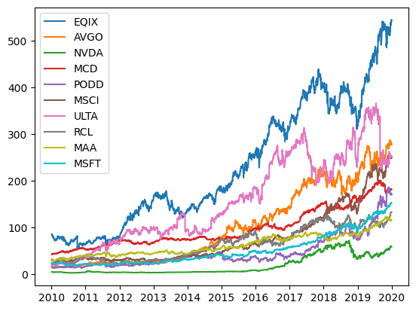

*Figure 2: The Close Prices of the Selected Stocks from 2010 to 2020*

# 2. Strategy Rules

Indicators used: RSI and MA Crossover

For this project, we will continue utilising our midterm strategy of MA Crossover with the RSI indicator. However, we will be enhancing it by having stop losses in place. Stop-loss strategies can prevent investors from holding their losing investments too long by automatically prompting the sales of losing investments can reduce the effective holding periods on losing investments (Lei, 2008).

The relative strength index (RSI) is a momentum indicator that measures the speed and magnitude of a security's recent price changes to evaluate overvalued or undervalued conditions in the price of that security. RSI is a strong predictor in the stock market due to human psychology and investor’s reaction to price actions, and is effective in predicting stock prices especially in “bear” markets (Tuomo, 2011).  
  
A moving average (MA) smooths out price trends by filtering out the noise from random short-term price fluctuations. A Long Term Moving Average can show the prevailing trend of an asset, while a Short Term Moving Average reflects on recent price movements and reacts quickly to price fluctuations. Combining the 2 MAs will then allow us to get buy/sell signals through a Golden Cross (STMA > LTMA) indicating a buy signal and a Death Cross (STMA < LTMA) indicating a sell signal.

## 2.1 Entry

**Buy Condition:**

We will buy when either one of the following is fulfilled:

1. RSI falls below 30, indicating potential undervaluation.
2. Short-Term Moving Average (STMA) crosses above the Long-Term Moving Average (LTMA) in a Golden Cross scenario.

**Sell Condition:**

We will sell when either one of the conditions is fulfilled:

1. RSI surpasses 70, indicating potential overvaluation.
2. Short-Term Moving Average (STMA) crosses below the Long-Term Moving Average (LTMA) in a Death Cross scenario.

## 2.2 Exit

For this enhanced version, we have taken into account stop-losses and taking profits in our strategy. This will help us seize the opportunity to reduce our losses on bad calls and to get some profits while our strategy is working. Both the stop loss and take profit percentages are parameters that we will be tuning as well in the training process.

**Stop loss:**

We will exit when the close price is a preset stop loss percentage below the bought-in price.

**Take profit:**

We will exit when the close price is a preset take profit percentage above the bought-at price.

## 2.3 Position Size

We will allocate equal weightage of capital on each stock. This is because of literature that suggests that equal-weighted (EW) portfolios have outperformed their value-weighted (VW) counterparts over multiple decades in various investment universes (Swade, 2022).

## 2.4 Risk Management

In our stock selection, we have already taken into account many factors to ensure that our portfolio is strong and diversified enough such that we will not be affected by unsystematic risks that can take place within a company, or a particular sector.

To prevent losing too much if our strategy falsely enters the market, we have implemented a stop-loss in order to prevent losing too much of our capital. Also, to ensure that we capture profits before the market decides to go against our favour, we will have a take profit condition.

# 3. Variables and Parameters of Strategy

The following parameters will be tuned during the training process to find the most optimal value for our strategy:

1. Moving Average Short Term Window and Moving Average Long Term Window
2. RSI window
3. RSI upper and lower bound
4. Stop loss ratio
5. Take profit ratio

# 4. Parameters used for training

For the parameters that we used in our training, we used the following for the 5 variables defined previously:

1. Moving average period (short term, long term)
   * [ [20, 50], [20,100], [20,150] ]
   * [ [50,100], [50,100], [50,200] ]
2. RSI window
   * 6, 10, 15
3. RSI lower and upper bound
   * [20,70], [20,80], [30,70], [30,80]
4. Stop loss ratio
   * 0.15, 0.2, 0.25
5. Take profit ratio
   * 0.05, 0.1, 0.15

The optimal variation which generated highest return is:

1. Moving average period (short term, long term) = 50, 100
2. RSI window = 6
3. RSI lower and upper bound = 30, 70
4. Stop loss ratio= 0.25
5. Take profit ratio = 0.05

## 4.2 Backtesting

Given that we have selected our list of stocks with the appropriate parameters from 2010 - 2015, we will then use an equal-weight approach for the weights of each stock to test our strategy against data of S&P500 stock prices from 2016-2019.

We have chosen the time period 2016-2019 for various reasons:

1. Prevention of Data Leakage

By taking the period that is just after the training period, we can prevent data leakage - which is when information from the future influences the training of the model which may cause the model to not be generalizable to new unknown data.

1. Simulation of Real-World Performance

By taking the period that is just after the training period, this is a more realistic simulation of real-world predictive performance since the main goal of a predictive model is to make accurate predictions on new, unseen data. By training the model on historical data and testing it on a separate set of data that comes after the training period, we can simulate real-world conditions more accurately.

# 5. Unique Features and Ideas

## 5.1 Idea/Feature 1: Multifaceted Stock Selection Approach

In our stock selection process, instead of only computing correlation, we also considered various aspects, including fundamental criteria, technical analysis indicators and diversification to ensure that our portfolio is resistant to market shock and generate superior returns.

We created our stock pool for selection from the S&P 500, which has a strict criteria on stocks’ market capitalization, liquidity and positive earnings. The strong balance sheets ensure that these companies have better resilience to market shocks, and thus will have better performance in the long term.

In addition, technical analysis also identifies trends and momentum. The application of the Mark Minervini Trend template screener ensures a systematic filter based on specific technical criteria such as SMA crossovers, 52-week high and low indicators, helping us filtering potentially best performing stocks for our testing period. Lastly, we computed correlation coefficients to select top 10 least correlated stocks, so their diversification could serve as a risk management strategy to mitigate overall portfolio volatility.

## 5.2 Idea/Feature 2: Exit Strategy

Our exit strategy incorporated both stop loss and take profit actions, making it a dynamic and adaptable component of our overall trading strategy. Stop loss serves as a proactive risk mitigation tool and take profit secures gains before potential market reversals.

Moreover, the stop loss and take profit percentages are treated as parameters to be optimised by backtesting, adding flexibility in response to the dynamic market.

# 6. Strategy Results

We used S&P 500 as a benchmark as all of our stocks were selected from S&P 500.

## 6.1 Training Performance

| Annual Regular Return | Annual Standard Deviation | Annual Sharpe Ratio | Return on Investment | Max Drawdown |
| --- | --- | --- | --- | --- |
| 13.36 % | 10.75 % | 1.24 | 101.4 % | 17.23 % |

Benchmark performance in training period:

| Annual Regular Return | Annual Standard Deviation | Annual Sharpe Ratio | Return on Investment | Max Drawdown |
| --- | --- | --- | --- | --- |
| 10.54 % | 15.91 % | 0.66 | 82.1 % | 21.55 % |

We were able to obtain a performance that greatly outperforms the S&P 500 index in returns, volatility and our investment doubled with our strategy in the training period.

## 6.2 Testing Performance

| Annual Regular Return | Annual Standard Deviation | Annual Sharpe Ratio | Return on Investment | Max Drawdown |
| --- | --- | --- | --- | --- |
| 3.21 % | 8.38 % | 0.38 | 12.0 % | 19.79 % |

Benchmark performance in training period:

| Annual Regular Return | Annual Standard Deviation | Annual Sharpe Ratio | Return on Investment | Max Drawdown |
| --- | --- | --- | --- | --- |
| 12.53 % | 12.86 % | 0.97 | 60.1 % | 22.04 % |

However, in the testing period, we were unable to replicate our performance and our strategy fell short of the benchmark.

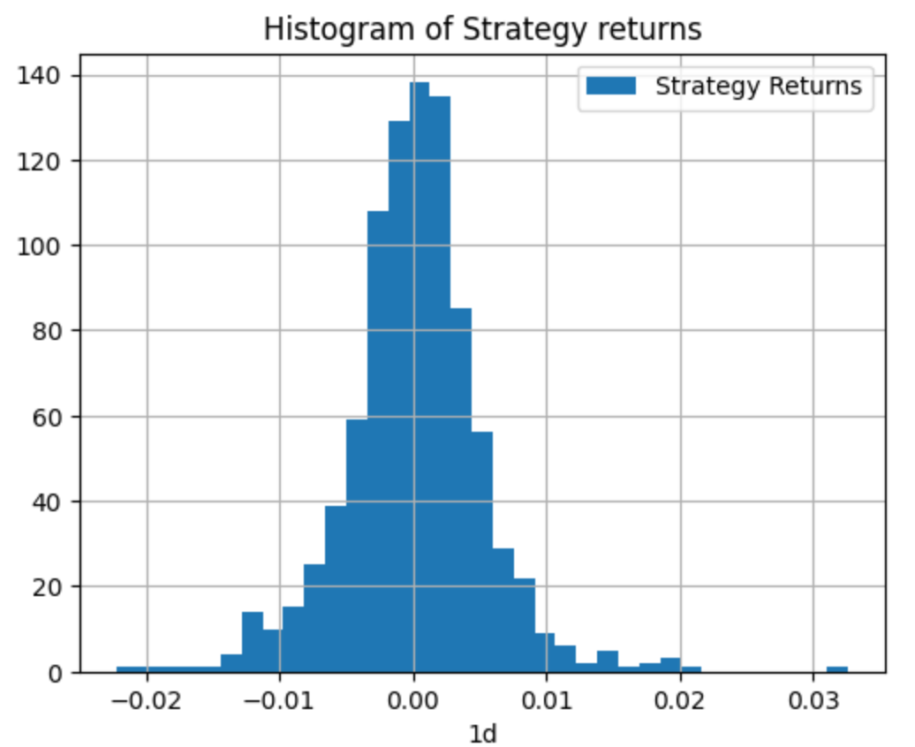

*Figure 3: Histogram of Strategy Returns on Test Data*

When we take a look at our Testing Performance when looking at the histogram, we can observe that the assumption of normal returns can be clearly seen.

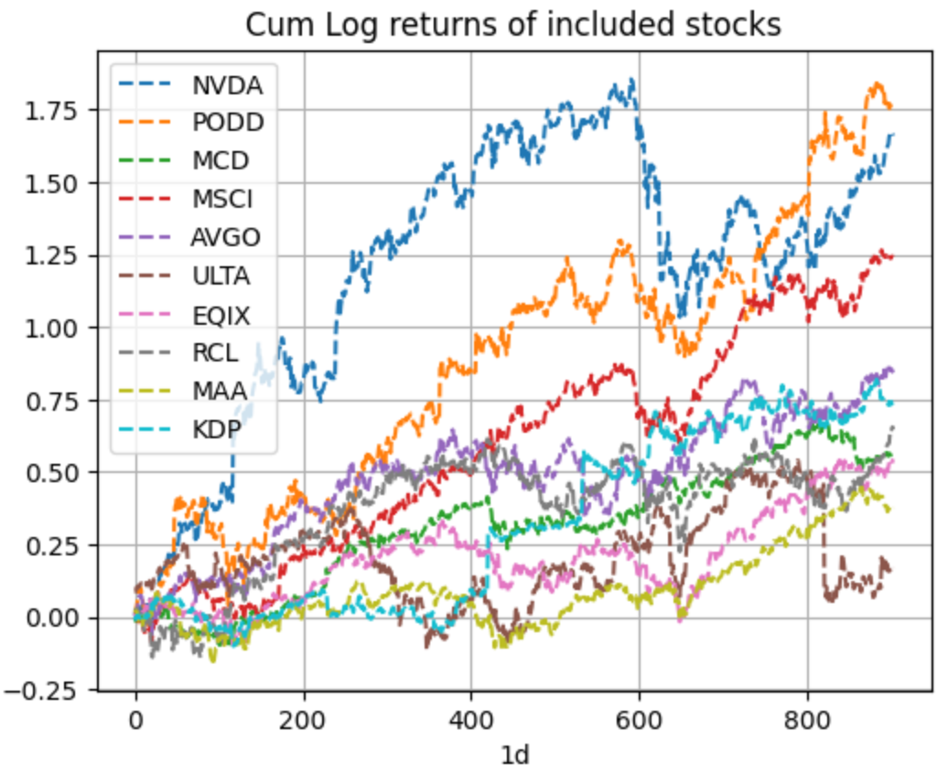

*Figure 4: Log Returns of Individual Stocks in Test Data*

From the individual returns of each stock, we can see that all the stocks in our portfolio generally show an increasing trend, which shows that our stock selection strategy has been performing as we expected.

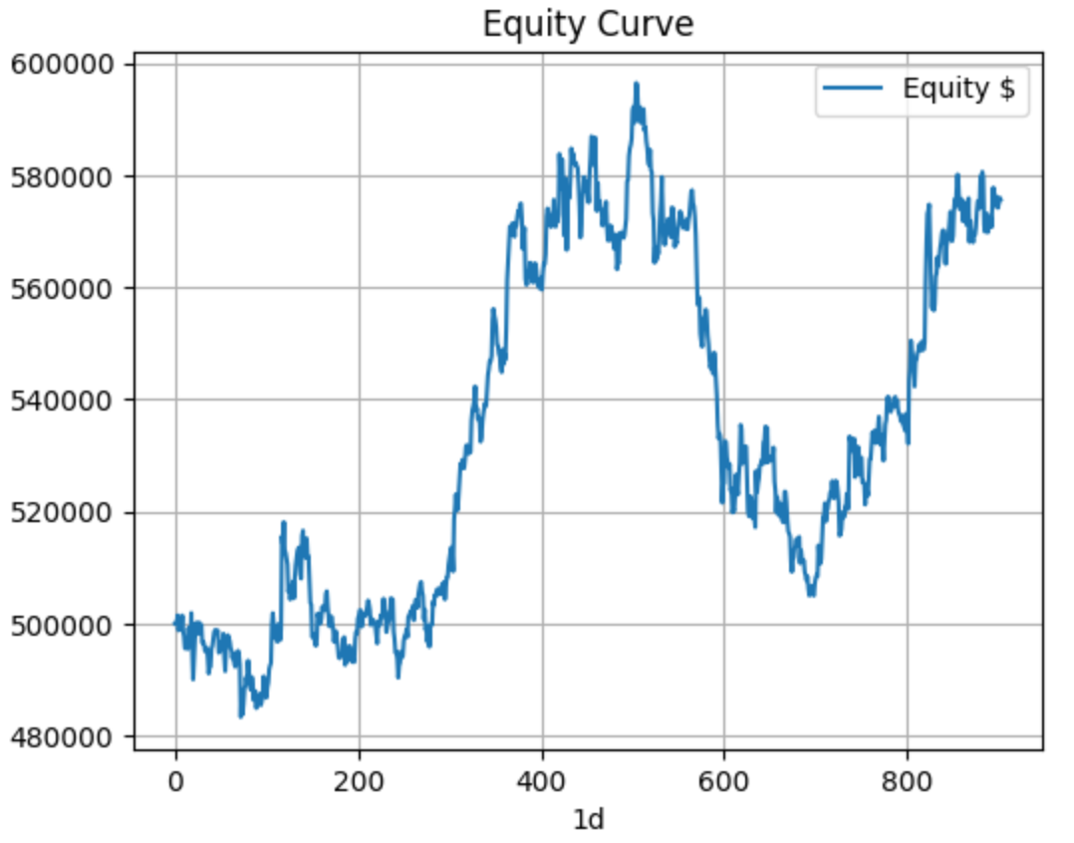

*Figure 5: Equity Curve for Test Data*

From the Equity Curve, we can observe that with an original budget of $500,000, we made an overall gain of 20% throughout the testing period.

# 7. Reflections

## 7.1 Strengths

1. Trend Identification

Moving averages help identify the direction of the trend, and crossovers (such as the golden cross and death cross) can signal potential trend reversals. Combining this with RSI, which measures the strength of a trend, can provide a more comprehensive view of the market conditions.

1. Risk management

Our portfolio has a low risk and stable returns throughout the training and testing period, making it a suitable portfolio for conservative investors.

1. Versatility

The strategy can be adapted to different time frames and financial instruments. It's versatile enough to be applied to various trading styles, such as day trading, swing trading, or even longer-term investing.

## 7.2 Weaknesses

1. Equal weight approach for capital allocation

Our trading strategy adopted an equal capital allocation approach for all selected stocks. This approach may not fully exploit opportunities presented by varying capital allocation. Certain stocks may have stronger signals or lower risks, but our approach did not differentiate them in capital allocation.

For future extension, it would be valuable to develop a system that incorporates risk-adjusted weights, allowing for a more flexible approach to capital allocation based on factors such as volatility and historical performance.

1. Lack of Fundamental Analysis

For the stock selection and strategy, it mostly incorporates technical analysis and correlation, and does not explicitly consider fundamental factors. This then poses the question if our strategy is missing out on the benefits of considering fundamental analysis to approach our trading in a more holistic manner.

1. All stocks are positively correlated

As the stocks are all under the same benchmark (S&P500), they were all found to be positively correlated to one another, which made it such that during the selection of stocks, it was not possible to select stocks that were negatively correlated to one another. As such, we picked only the stocks that had the least correlation to one another.

The positive correlation increases the overall risk of the portfolio, thus mitigating the effects of diversification to a certain extent.

## 7.3 Comments

More indicators, such as Bollinger Bands, Average True Range, and more can be considered in future to make a better combination that can provide a better result from trading. However, combining too many indicators would lead to a more complex strategy that may not enter the market as much, and thus lose out on potential profits. This was partly why we decided on a maximum of only 2 indicators to use for our strategy, and mostly cycled around different pairs before deciding on RSI and MA crossovers.

# 8. Extension (After presentation)

This section was added after the presentation in hopes of further testing our strategy after receiving feedback regarding selection bias. We then tested our strategy across all stocks in the S&P500 index from 2016 to 2019. The most optimal set of stocks that gave the best performance is (STX, BBWI, SEDG, FFIV, DXCM, VRSK, HSY, RSG, WRB, CTLT).

| Annual Regular Return | Annual Standard Deviation | Annual Sharpe Ratio | Return on Investment | Max Drawdown |
| --- | --- | --- | --- | --- |
| 12.31 % | 7.32 % | 1.68 | 44.6 % | 5.79 % |

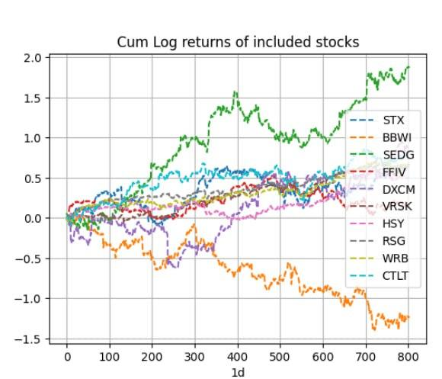

*Figure 6: Cum Log returns of stock*

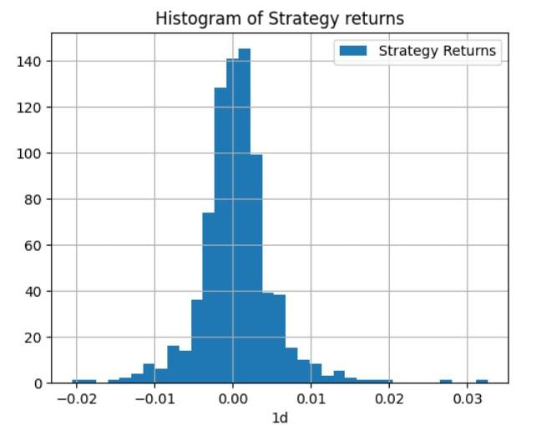

*Figure 7: Histogram of Strategy Returns*

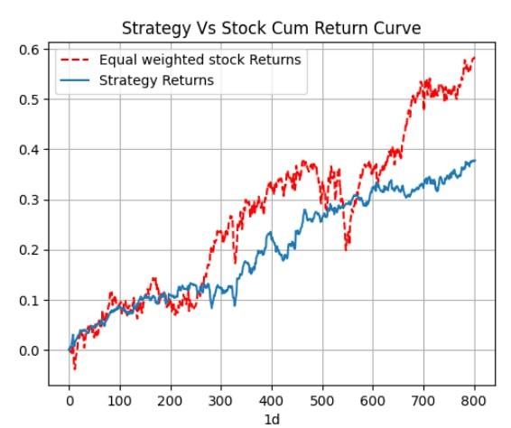

*Figure 8: Stock Cum Returns VS Strategy Cum Returns*

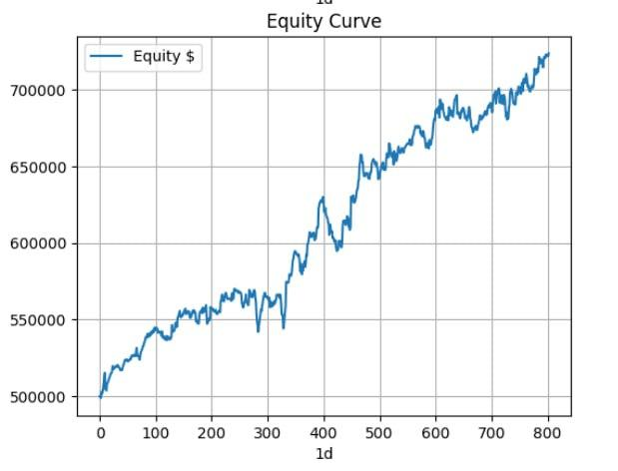

*Figure 9: Equity Curve*

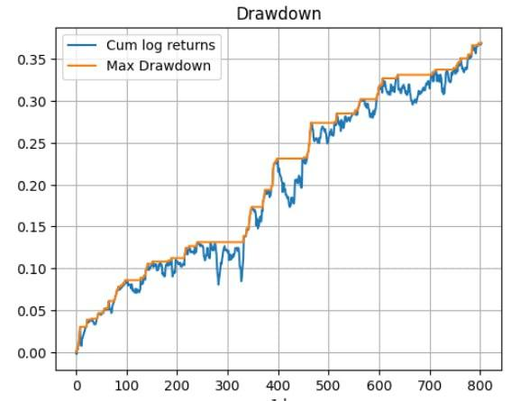

*Figure 10: Drawdown Plot*

It shows that there is an opportunity to improve our strategy performance by varying the stocks selection over time to avoid selection bias.

# 9. References

George, Thomas J. “The 52-Week High and Momentum Investing.”

Grobys, Klaus. “Better Not Forget: On the Memory of S&P 500 Survivor Stock Companies.” *Journal of Risk and Financial Management*, no. 2.

Lei, Adam Y.C. “The Value of Stop Loss Strategies.”

Harry Markowitz, 1952. "Portfolio Selection," Journal of Finance, American Finance Association, vol. 7(1), pages 77-91, March

Minervi, Mike. *Think & Trade Like a Champion: The Secrets, Rules & Blunt Truths of a Stock Market Wizard*.

Narayan, S., Rehman, M. U., Ren, Y., & Ma, C. (2023). Is a correlation-based investment strategy beneficial for long-term international portfolio investors? Financial Innovation, 9(1). https://doi.org/10.1186/s40854-023-00471-9

Rathburn, Pete. “Altman Z-Score: What It Is, Formula, How to Interpret Results.” *Investopedia*, https://www.investopedia.com/terms/a/altman.asp. Accessed 10 October 2023.

Sobreiro, Vinicius Amorim. “The profitability of moving average trading rules in BRICS and emerging stock markets.”

Swade, Alexander. “Why Do Equally Weighted Portfolios Beat Value-Weighted Ones?”

Tuomo, Tolonen. “AN EMPIRICAL TEST OF A 14-DAY MONEY FLOW INDEX AND RELATIVE STRENGTH INDEX HYBRID’S PREDICTIVE ABILITIES ON HELSINKI, OSLO AND STOCKHOLM STOCK EXCHANGES.”